### 

**INTERNATIONAL WEBINAR**

**on**

**PATENTS AND PATENTABILITY**

1st June 2024

**Faculty Coordinator: Mr. Jobin Scaria**

**Student Coordinator: Ms. Rohini Kumari S, I BBA**

**Abstract of the Event:**

International webinar on “Patents and Patentability” by Ms. Priyanka Prasad, Assistant Professor, Dr. Ambedkar Government Law College, Puducherry was organised by the NDLI, Department of Library and Information Centre and IPR Cell in association with the Department of Management and IQAC, Christ College of Science and Managementon 1st June 2024.

**Programme Objectives:**

* To expose students to intellectual property rights
* To evaluate the steps and importance of filing patents and patentability

**Programme Schedule:**

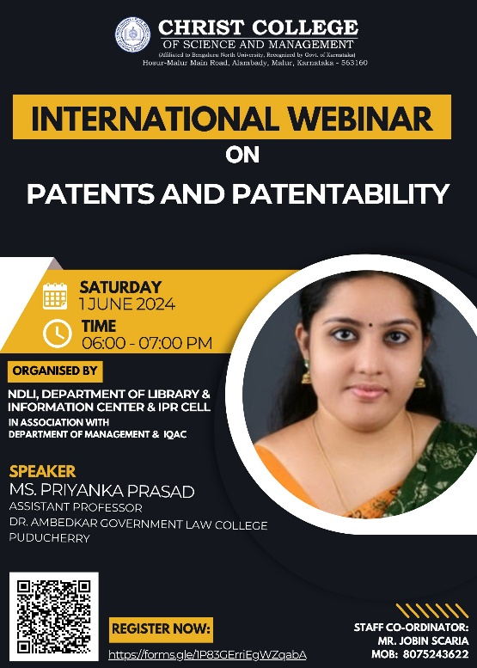

**Report in Brief:**

International webinar on “Patents and Patentability” by Ms. Priyanka Prasad, Assistant Professor, Dr. Ambedkar Government Law College, Puducherry was organised by the NDLI, Department of Library and Information Centre and IPR Cell in association with the Department of Management and IQAC, Christ College of Science and Managementon 1st June 2024.

The event's details were circulated among different social media platforms and the registration link for the event was shared with all known people. The webinar covered in details Intellectual Rights, different types of intellectual properties, acts related to the IPR and Patents, steps to file a patent, patentability and the cases where the patent requests were denied was elaborately discussed.

The webinar had one participant from Sri Lanka and two participant from Pakistan.

**Summary of the Program:**

|  |  |  |  |  |  |  |
| --- | --- | --- | --- | --- | --- | --- |
| Type of the Event (Experiential/ Problem Solving Methodology/ Participative Learning) | Mode of the Programme (Online/Offline/Hybrid) | Level – Intercollegiate/ National/International/College | Name of the Resource Person/ Chief Guest with contact details (Mobile, Email) | Number of Colleges participated | Number of Internal Participants | Number of External Participants |
| Participative Learning  01-06-2024 | Online | International | Ms. Priyanka Pradeep,  Assistant Professor,  Dr. Ambedkar Government Law College  Puducherry  Mob: 9645935309 | 58 | 94 | 126 |

**Link to Registered participants:**

[**https://docs.google.com/spreadsheets/d/1xVc1EkSUTsSPpFQMUTldHj5onJ-t7k-9rDhu-492UV0/edit?usp=sharing**](https://docs.google.com/spreadsheets/d/1xVc1EkSUTsSPpFQMUTldHj5onJ-t7k-9rDhu-492UV0/edit?usp=sharing)

**Link to Participants List:**

[**https://docs.google.com/spreadsheets/d/16_AD5M4J5JTy-bd6ZC5vkU5ciIBB3pViLcoI-XYLnMQ/edit?usp=sharing**](https://docs.google.com/spreadsheets/d/16_AD5M4J5JTy-bd6ZC5vkU5ciIBB3pViLcoI-XYLnMQ/edit?usp=sharing)

**Link to the Webinar Intro PPTs:**

<https://docs.google.com/presentation/d/12xOFnaImdKkLP8rqm7HH5DwWBVGUHbcb/edit?usp=sharing&ouid=116341947838371475136&rtpof=true&sd=true>

**Link to Certificates:**

<https://drive.google.com/drive/folders/1osRGQ6NBegEVlbH2UcJtGplTxW2lm2aW?usp=sharing>

**Event Photographs:**

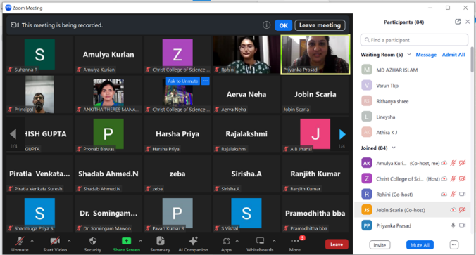 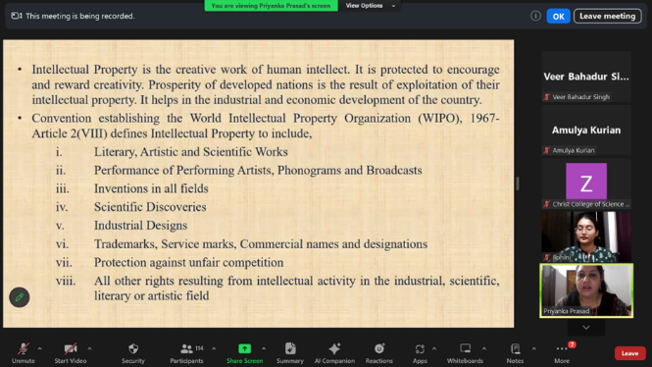

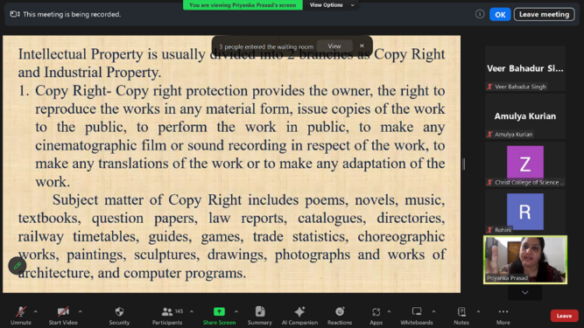 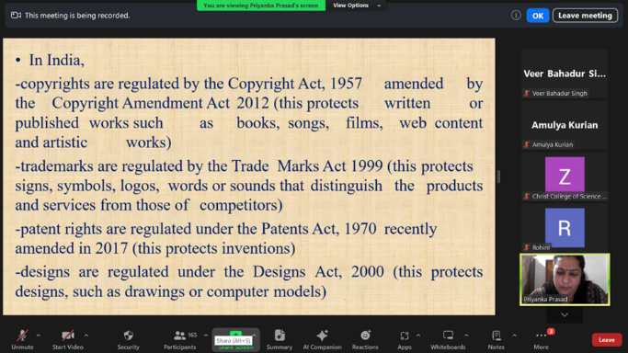

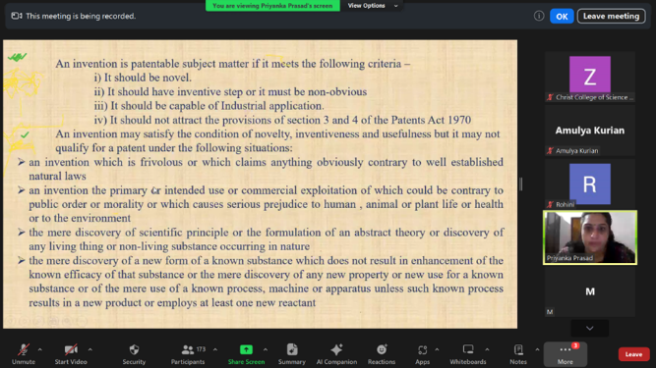 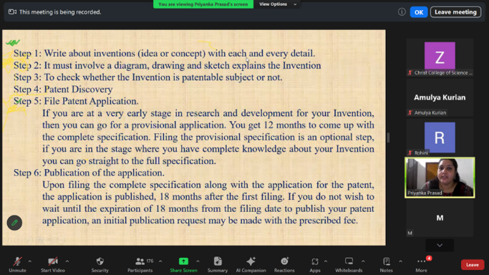

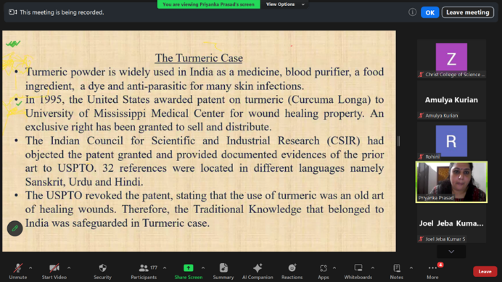 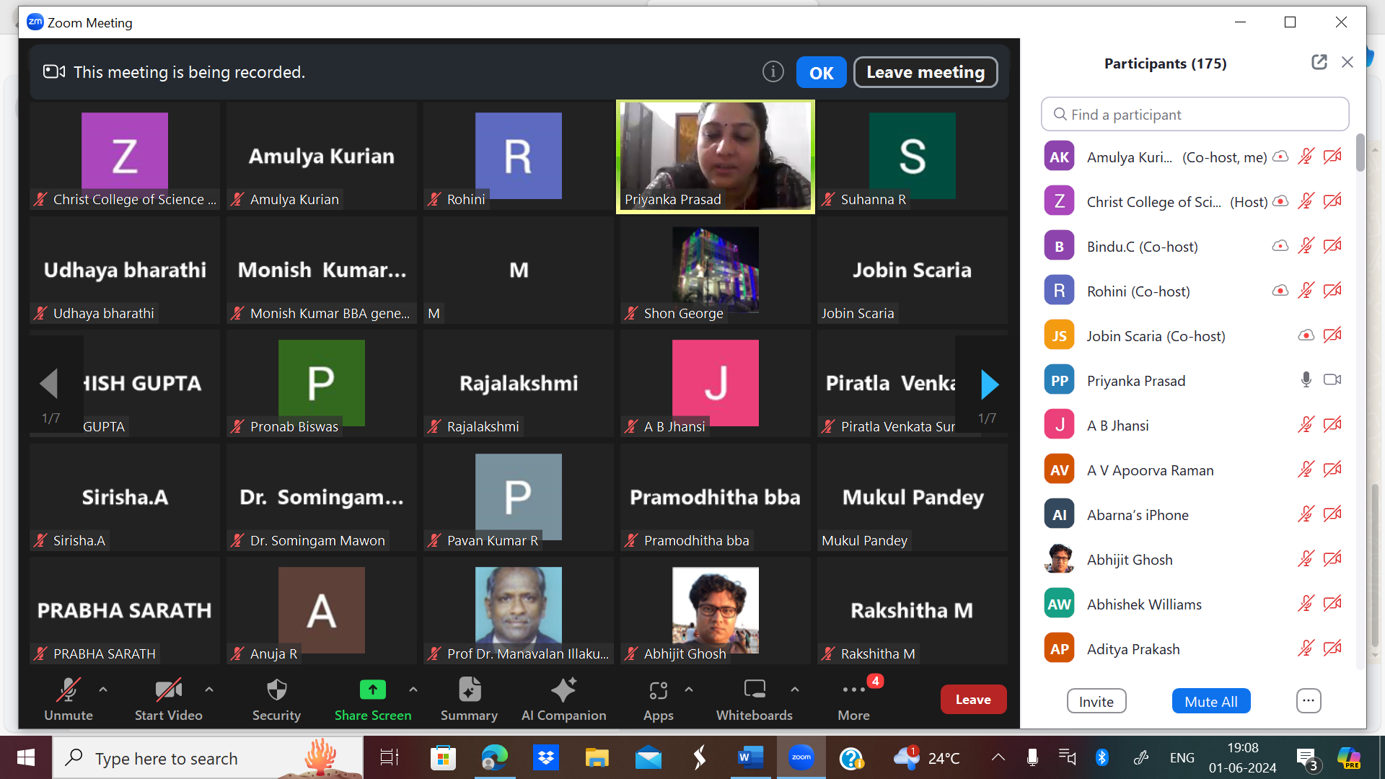

**Snapshots:**

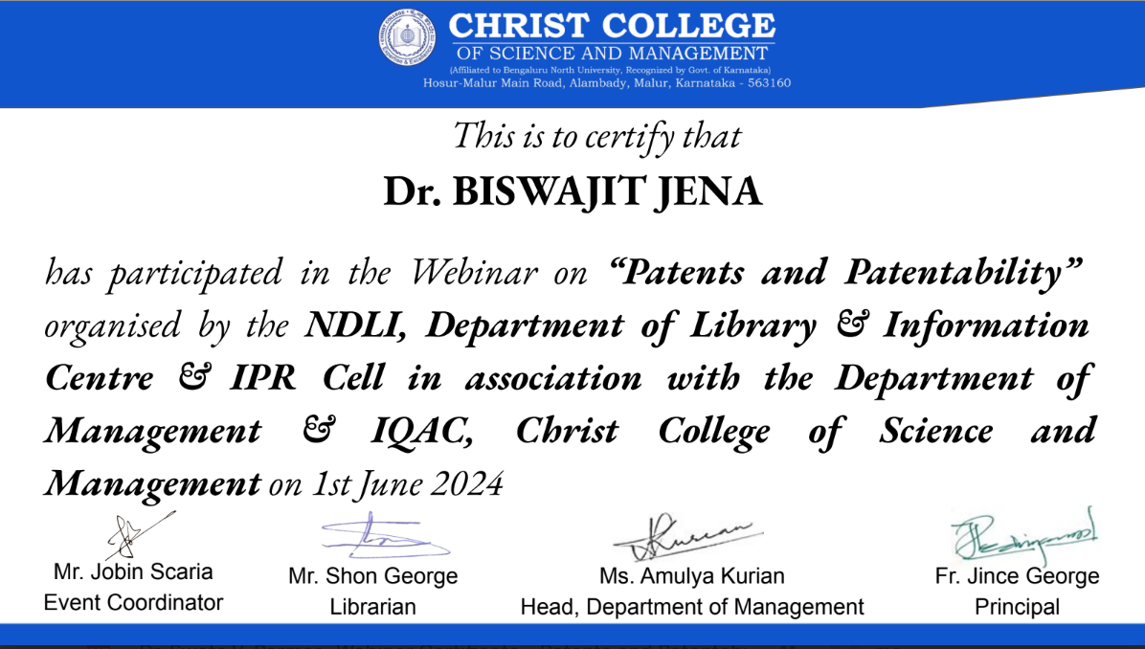

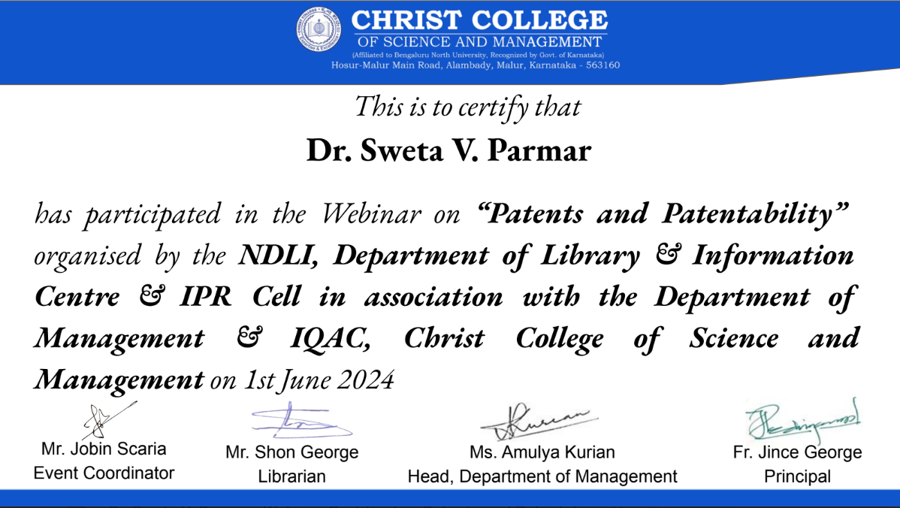

**Outcomes:**

* Compared and explained intellectual property rights in detailed
* Evaluated the steps and importance of patent filing and the patentability of products

**Faculty Co-Ordinator Head of Department Principal**

**Appendix:**

**Emcee Script**

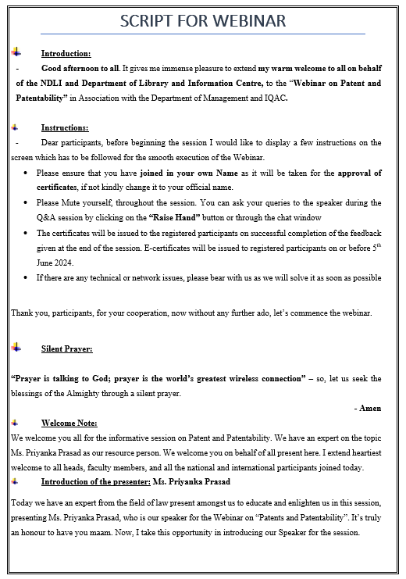

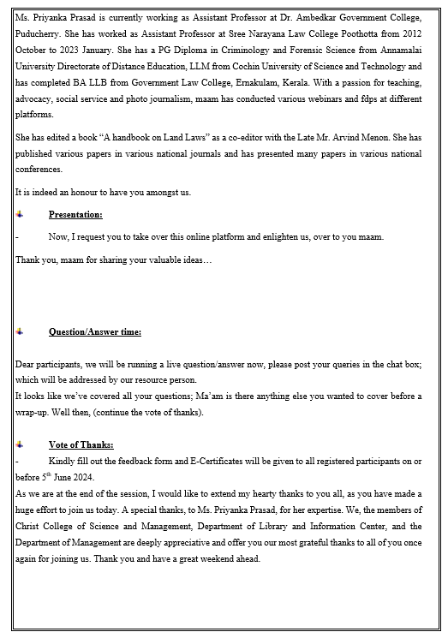

**Thank You Note for the Speaker:**

